An Honestly Fun Camp

Will couldn’t wait for September when school would start. I t was early August, and he was at the same summer camp he had been going to for the last five years. His dad went to the camp when he was a boy and loved it, so Will didn’t want to disappoint his dad by telling him that he didn’t even like it.

By the middle of August, Will had had more than enough. He had had enough of the horses, enough of the baseball games, enough of the canoeing and enough of the lousy camp food.

He wrote to his mom and asked her if she would pick him up early, but he didn’t want his mom to tell his dad. She responded in a letter which said, “I can’t do that. I am always honest with your dad. I f you really want to leave, I will talk to him about it.”

Will was still too worried about disappointing his dad, so he wrote back to his mom that he would stay for the last two weeks and try to make the best of it. He asked his mom if she would make his favorite meal when he got home.

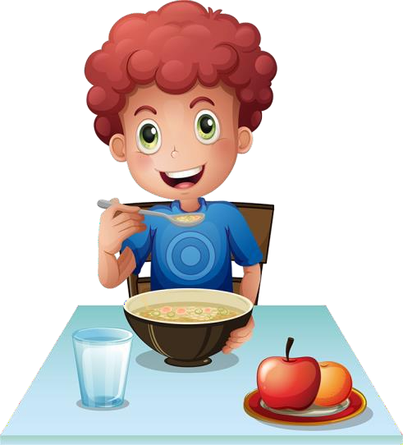During that last week, Will was looking so forward to the meal his mom would be making that every time he ate a camp meal, he imagined he was eating his mom’s cooking. All of a sudden, the food didn’t taste as bad.

Will decided to be honest with his camp counselors. He told the head horseback counselor that he wasn’t comfortable with the horse he had been assigned. The counselor asked Will which horse he might feel better riding. Will was then assigned to Misty for the last week, and he started to like horseback riding.

Will never like playing baseball because he didn’t like playing 1st base. He told the baseball counselor, and the counselor switched him to play catcher. Will started to actually like baseball.

As for canoeing, Will always ended up sitting in the bow of the canoe. He told his counselor that he would like to try sitting in the stern. Once he was able to take on the role of the stern paddler, he started to enjoy canoeing because he liked steering the canoe.

When Will’s parents came to pick him up from camp, he said to them in all honesty, “This was the best summer at camp ever.” He then added that he couldn’t wait for next year’s camp, and he might even want to stay for an extra week or two.

